Practical file Python SEM-1

Niket Aggarwal

25739

B.Sc.(Hons) CS

Q1- Write a program to find the roots of a quadratic equation.

Program:
from math import sqrt
print('To find root of quadratic equation enter a,b,c')
while True:
try:
a=eval(input('Enter a:'))
if type(a) not in [int,float] or a==0 :
print('Entered data is not correct acc. to a')
else:
while True:
b=eval(input('Enter b:'))
c=eval(input('Enter c:'))
if type(b) in [int,float] and type(c) in [int,float]:
break
else:
print('Enter a integer')
break
except:
print('Enter Numbers only')
D=b**2-(4*a*c)
if D>=0:
print('so roots of Equation:',(-b+sqrt(D))/(2*a),end=',')
print((-b-sqrt(D))/(2*a))
else:
print('as D<0 so no real roots')

Output:

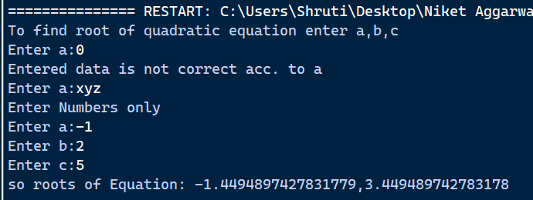

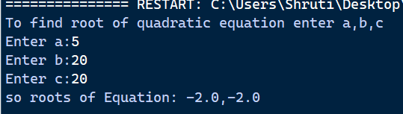

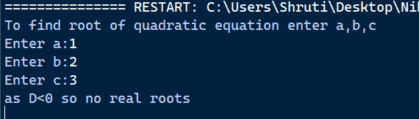

Q2- Write a program to accept a number ‘n’ and
a. Check if ‘n’ is prime.
b. Generate all prime number till ‘n’.
c. Generate first ‘n’ prime number.
This program may be done by using functions.

Program:
def prime(n):
for i in range(2,n):
if n%i==0:
return False
return True
while True:
try:
n=int(input('Enter a number n so to perform some prime number task:'))
if n<=0:
print('Enter interger greater than 0')
else:
break
except:
print('Enter interger greater than 0')
if prime(n):
print('a)',n,'is prime')
else:
print('a)',n,'is not prime')
print('b) All prime number till',n,'is:',end='')
for i in range(2,n+1):
if prime(i):
print(i,end=' ')
print()
print('c) first',n,'prime number are:',end='')
c=0;a=2
while c!=n:
if prime(a):
print(a,end=' ')
c+=1
a+=1

Output:

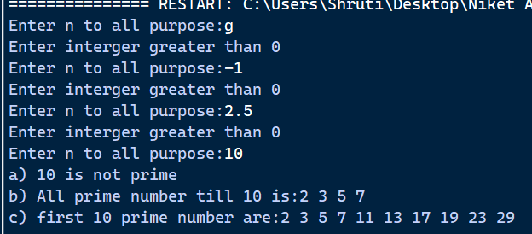

Q3-Write a program to create a pyramid of the character ‘*’ and a reverse pyramid.

Program:
print('pyramid of "*"\n')
n=2
for i in range(3):
print(" "*(6-i*2),end='')
for j in range(1,n):
print("*",end=' ')
n=n+2
print()
for i in range(3,8):
print(" "*(i*2-6),end='')
for j in range(1,n):
print('*',end=' ')
n=n-2
print()

Output:
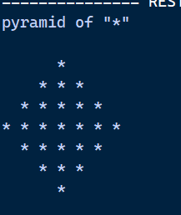

Q4- Write a progra that accepts a character and performs the following:
a. print whether the character is a letter or numeric digit or a special character.
b. if the character is a letter, print whether the letter is uppercase or lowercase.
c. if the character is a numeric digit, prints its name in text(e.g. if input is 9, output is Nine)

Program:
print('To check the type and details of entered character')
d={1:'One',2:'Two',3:'Three',4:'Four',5:'Five',6:'Six',7:'Seven',8:'Eight',9:'Nine',0:'Zero'}
a=input('Enter:')
if a.isdigit():
print(a,'is numeric digit')
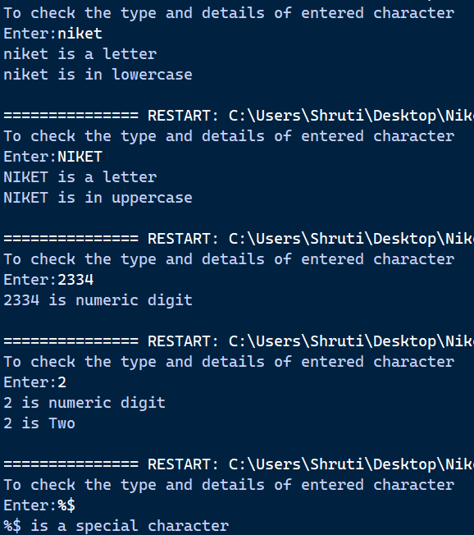
if len(a)==1:
print(a,'is',d[int(a)])
elif a.isalpha():
print(a,'is a letter')
if a.isupper():
print(a,'is in uppercase')
elif a.islower():
print(a,'is in lowercase')
else:
print('Mix of both lower and upper')
elif a.isalnum()!=True and a.isspace()!=True:
print(a,'is a special character')
else:
print('Not recognised')

Output:

Q5- Write a program to perform the following operations on a string
a. Find the frequency of a character in a string.
b. Replace a character by another character in a string.
c. Remove the first occurrence of a character from a string.
d. remove all occurrences of a character from string.

Program:
print('To perform some string opeartion enter string and a character from that string')
a=input('Enter a String:')
c=input('Enter character:')
print('a) Frequency of',c,'in',a,'is:',a.count(c),'\n')
b=input('b) By which character you want to replace '+c+':')
print('New string is;',a.replace(c,b),'\n')
print('c)Removing first occurence')
print('Original string',a)
x=a.find(c)
if x==-1:
print('Character is not in string')
print('No change\n')
else:
print('New string:',a[:x]+a[x+len(c):],'\n')
print('d)Removing all occurrence')
y=0;d=a
for i in range(a.count(c)):
x=a.find(c)
a=a[:x]+a[x+len(c):]
y+=1
if y==0:
print('Same is old string:',a)
else:
print('Old string:',d)
print('New string:',a)

Output:
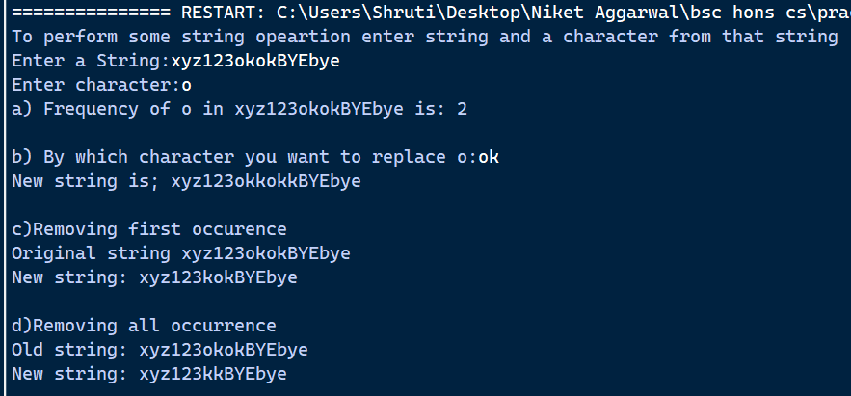

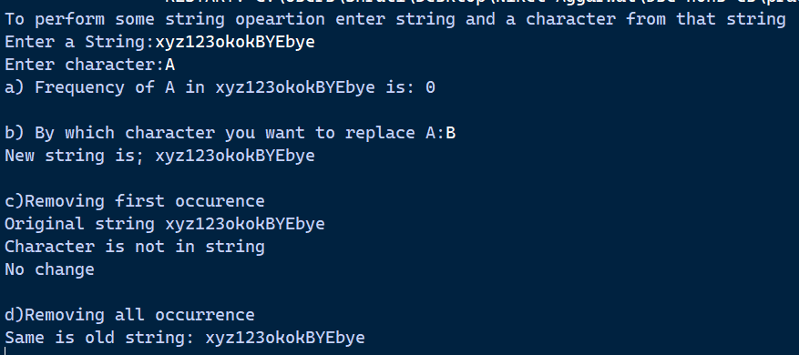

Q6-Write a program to swap the first n character of two string.

Program:
print('Swaping first n character from two string')
a=input('Enter string1:')
b=input('Enter string2:')
while True:
try:
n=int(input('Enter n character to be swap:'))
if n<0:
print('Enter positive number')
else:
break
except:
print('Enter number only')
x=b[:n]+a[n:]
b=a[:n]+b[n:]
a=x
print('NEW after swaping')
print('String1:',a)
print('String2:',b)

Output:
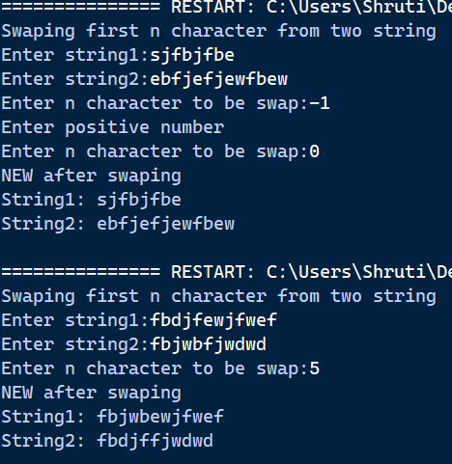

Q7-Write a program that accepts two strings and returns the indices of all the occurrences of the second string in the first string as a list. If the string is not present in the first string then it should return -1.

Program:
print('Enter two string to check that the second string occur in first or not')
def checkstr(a,b):
l=[]
if a.count(b)==0:
return -1
else:
c=len(b)
for i in range(len(a)):
if a[i:i+c].lower()==b.lower():
l.append(i)
return l
a=input('Enter first string:')
b=input('Enter second string:')
l=checkstr(a,b)
if l==-1:
print('No occurence of',b,'in',a,'(-1)')
else:
print(b,'occurs in',a,'on indices:',l)

Output:
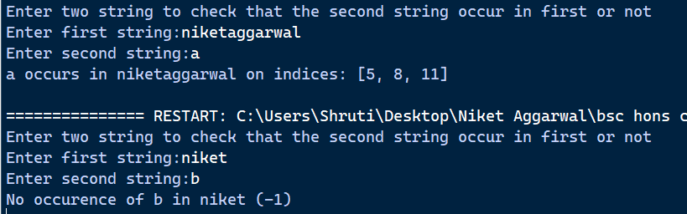

Q8-Write a program to create a list of cubes of only the even integers appearing in the input list(may have elements of other types also) using the following:

a)’for’ loop.
Program:
while True:
l=eval(input('Enter a list:'))
if type(l)==list:
break
else:
print('Enter list only\n')
cl=[]
for i in l:
if type(i)==int and i%2==0:
a=i**3
cl.append(a)
print('Cube of even number in given list:',cl)

b) list comprehension.
Program:
while True:
l=eval(input('Enter a list:'))
if type(l)==list:
break
else:
print('Enter list only\n')
ccl=[a**3 for a in l if type(a)==int and i%2==0]
print('Cube of even number in given list:',ccl)

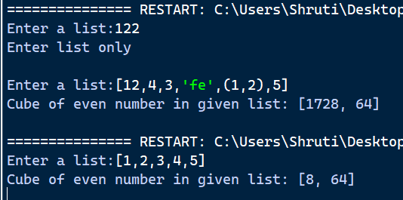
output

Q9- Write a program to read a file and
a. Print the total number of characters, words and lines in the file.
b. Calculate the frequency of each character in the file. Use a variable of dictionary type to maintain the count.
c. Print the words in reverse order.
d. Copy even lines of the file to a file named ‘File1’ and odd lines to another file named ‘File2’.

Program:
print('File Name:Text.txt')
try:
f=open("Text.txt",'r')
f.close()
except:
print('\nFile doesnot exist first create it')
n=eval(input('How many lines do you want to add:'))
f=open('Text.txt','a')
for i in range(1,n+1):
a=input('Enter line'+str(i)+':')
f.write(a+'\n')
print('File created\n')
f.close()
#a
print("a)Total no. of character,words and lines in the file")
f=open("Text.txt",'r')
r=f.read()
print('Total number of character:',len(r))
l1=r.split()
print("Total number of words",len(l1))
l2=r.split("\n")
print(l2)
print('Total number of lines',len(l2)-1,'\n')
f.close()
#b
print('b)Calculating the frequency of each character in form of dictionary')
f=open("Text.txt",'r')
r=f.read()
freq={}
for i in r:
if i in " \n":
continue
a=r.count(i)
freq[i]=a
print('Frequency of each character is:',freq,'\n')
f.close()
#c
print('c)Printing words of file in reverse order')
f=open("Text.txt",'r')
rev=f.readlines()[::-1]
for i in rev:
l=i.split()[::-1]
for j in l:
print(j,end=' ')
print()
f.close()
#d
print('\nd)Copy even lines to File1.txt and odd lines to File2.txt')
f=open('Text.txt','r')
f1=open('File1.txt','w+')
f2=open('File2.txt','w+')
r=f.readlines()
c=1
for i in r:
if c%2==0:
f1.write(i)
else:
f2.write(i)
c+=1
print('Copy Done')
f.seek(0)
f1.seek(0)
f2.seek(0)
print('Text.txt:')
print(f.read())
print('File1.txt:')
print(f1.read())
print('File2.txt:')
print(f2.read())
f.close()
f1.close()
f2.close()

Output:

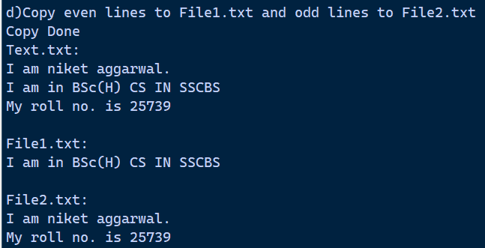
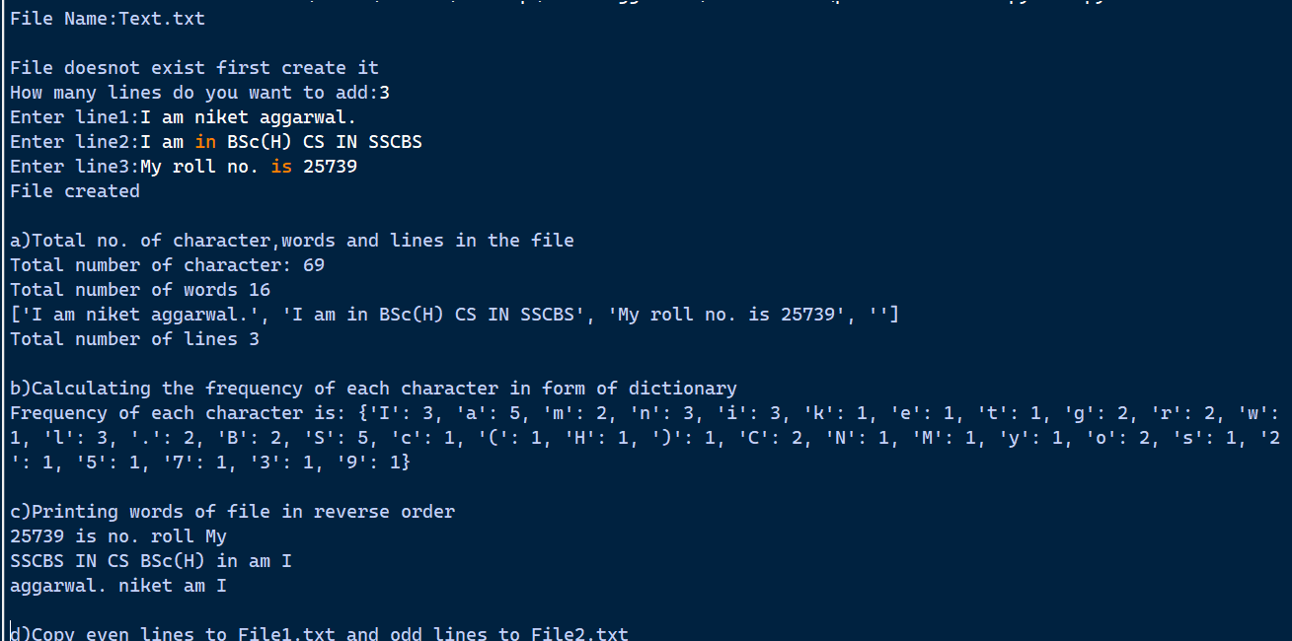

Q10- Write a function that prints a dictionary where keys are number between 1 and 5 and the values are the cubes of the keys.

Program:
def dict_cube():
d={}
for i in range(1,6):
d[i]=i**3
print("Dictionary:",d)
print('A dictionary that habe key between 1 and 5 and value as cube of key')
dict_cube()

Output:

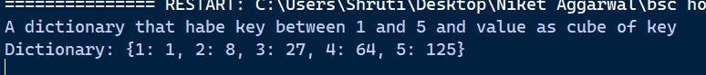

Q11- Consider a tuple t1=(1,2,5,7,9,2,4,6,8,10). Write a program to perform following operations:
a.Print half the values of the tuple in one line and half in the next line.
b. Print another tuple whose values are even numbers in the given tuple.
c. Concatenate a tuple t2=(11,13,15) with t1.
d. Return maximum and minimum value from this tuple

Program:
print('Tuple Operations:',end="")
t1=(1,2,5,7,9,2,4,6,8,10)
print(t1)
print("a)Half in one line and other half in second line")
l=len(t1)//2
print("First half:",t1[:l])
print("second half:",t1[l:],'\n')
print("b)Another Tuple with even values")
t=()
for i in t1:
if i%2==0:
t=t+(i,)
print('New tuple:',t,"\n")
t2=(11,13,15)
print("c)Concatenate")
print("Original:",t1)
print("To add:",t2)
print("Cancatenated:",t1+t2,"\n")
print("d)Max and Min value of the Tuple")
print("Max:",max(t1))
print("Min:",min(t1))
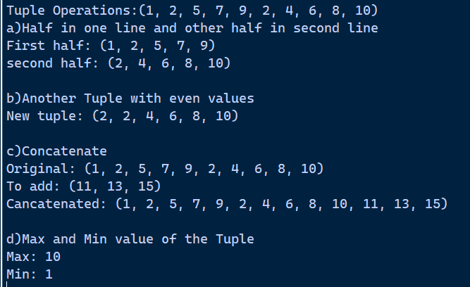
Output:

Q12-Define a class Employee that stores information about employees in the company. The class should contain the following:
(i) Data members- count (to keep a record of all the objects being created for this class) and for every employee: an employee number, Name, Dept, Basic, DA and HRA.
(ii) Function members:
a. __init__ method to initialize and/or update the members. Add statements to ensure that the program is terminated if any of Basic, DA and HRA is set to a negative value.
b. Function salary, that returns salary as the sum of Basic, DA and HRA.
c. __del__ function to decrease the number of objects created for the class.
d. __str __ function to display the details of an employee along with the salary of an employee in a proper format.

Program:
print("Class Employee is created to store information of Employee\n")
class Employee:
count=0
def __init__(self,empno,name,dept,basic,da,hra):
if basic<0 or da<0 or hra<0:
raise ValueError("Basic,DA and HRA must be non-negative values.")
self.empno = empno
self.name = name
self.dept = dept
self.basic = basic
self.da = da
self.hra = hra
Employee.count+= 1
def get_salary(self):
return self.basic+self.da+self.hra
def __del__(self):
Employee.count-=1
def __str__(self):
return f"EmployeeNo:{self.empno}\nName:{self.name}\nDepartment:{self.dept}\nBasic Pay:{self.basic}\nDA:{self.da}\nHRA:{self.hra}\nTotal Salary:{self.get_salary()}"
try:
E1=Employee(101,"Niket","AI Research",50000,10000,5000)
E2=Employee(102,"Riya","Data Science",60000,12000,6000)
print("Total Employee:",Employee.count)
print(E1.__str__(),'\n')
print(E2.__str__())
del E1
print('\nEmployee with id 101 id deleted')
print("Remaining Employees:",Employee.count)
print(E2.__str__(),'\n')
print(E1.__str__())
except ValueError as e:
print("Error:", e)
except:
print("Object not found")

Output:
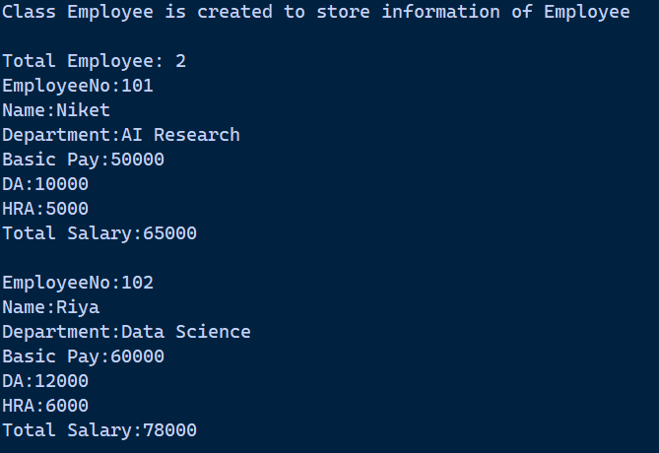
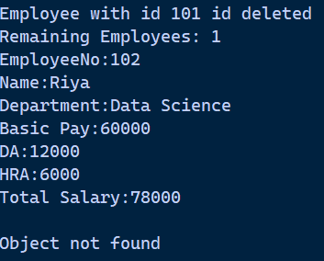

Q13- Write a program to define a class "2DPoint" with coordinates x and y as attributes. Create relevant methods and print the objects. Also define a method distance to calculate the distance between any two point objects.

Program:
print("Working with 2D Plan:")
import math
class Point2D:
def __init__(self,x,y):
self.x=x
self.y=y
def get_coordinates(self):
return f"({self.x},{self.y})"
def dist_between(self,other):
return math.sqrt((self.x-other.x)**2+(self.y-other.y)**2)
def main():
P1=Point2D(1,2)
P2=Point2D(3,4)
print("Point1:",P1.get_coordinates())
print("Point2:",P2.get_coordinates())
print("Distance between point1 and point2:",P1.dist_between(P2))
if __name__=="__main__":
main()

Output:
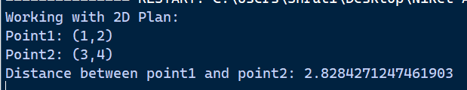

Q14- Inherit the above class to create a "3Dpoint" with additional attribute z. Override the method defined in "2DPoint" class , to calculate distance between two points of the "3DPoint" class.

Program:

#Above Class is already created
print("Working with 3D Plan:")
class Point3D(Point2D):
def __init__(self,x,y,z):
super().__init__(x,y)
self.z=z
def get_coordinates(self):
return f"Point({self.x},{self.y},{self.z})"
def distance(self,other):
return math.sqrt((self.x-other.x)**2+(self.y-other.y)**2+(self.z-other.z)**2)
def main():
P3=Point3D(1,2,3)
P4=Point3D(4,6,9)
print("Point3:",P3.get_coordinates())
print("Point4:",P4.get_coordinates())
print("Distance between point3 and point4:",P3.distance(P4))
if __name__=="__main__":
main()

Output:
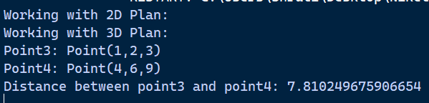

Q15- Write a program to accept a name from a user. Raise and handle appropriate exception(s) if the text entered by the user contains digits and/or special characters.

Program:
print('To check that the user enter name in correct format or not')
try:
a=input("Enter Username:")
if a=="" or a==" ":
raise ValueError("Username field cannot be empty")
for i in a:
if i.isspace():
pass
elif i.isalpha()==False:
raise ValueError("Given username is not correct it will not contain number/special character")
print("Entered username is correct that is:",a)
except ValueError as e:
print("\nError:",e)

Output:
